Q1 | Create a SQL query using a subquery in the WHERE clause to find all restaurants from a 'Restaurants' table whose average rating is higher than the average rating of all restaurants in the city.
Code | Table already created:  SELECT * FROM restaurants WHERE rating > ( SELECT AVG(rating) FROM restaurants );
Output | 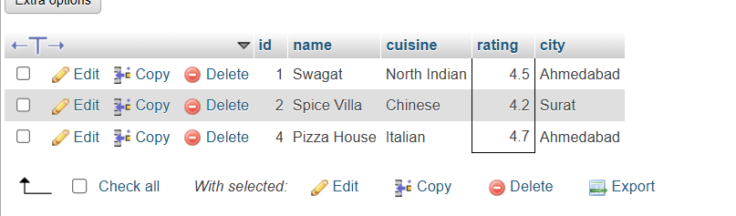

Q2 | Write a SQL query that uses a subquery in the SELECT statement to display each user's name from a 'Users' table along with the total number of orders they have placed from an 'Orders' table, like a summary you might see in a Zomato user profile.
Code | Create table users:  CREATE TABLE Users1 ( user_id INT PRIMARY KEY, user_name VARCHAR(50) );  Insert record:  INSERT INTO users1 VALUES (1,'Mayank'), (2,'Dipti'), (3,'Yarta'), (4,'priyanshu');  Create table orders:  CREATE TABLE Orders2 ( order_id INT PRIMARY KEY, user_id INT, amount DECIMAL(10,2), FOREIGN KEY (user_id) REFERENCES Users(user_id) );  Insert record:  INSERT INTO orders2 VALUES (101,1,500), (102,1,700), (103,2,250), (104,2,450), (105,2,900), (106,3,350);  Final Query  SELECT u.user_name, ( SELECT COUNT(*) FROM Orders2 o WHERE o.user_id = u.user_id ) AS total_orders FROM Users1 u;
Output | 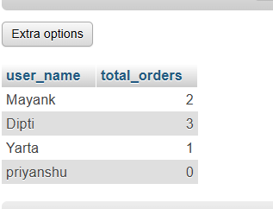

Q3 | Given a 'Movies' table and a 'Reviews' table, write a SQL query using IN with a subquery to list all movies that have at least one review with a rating of 5 stars, as seen in BookMyShow's top-rated section.
Code | Create table movie:  CREATE TABLE Movies ( movie_id INT PRIMARY KEY, movie_name VARCHAR(100) );  Insert data:  INSERT INTO Movies VALUES (1,'Avengers'), (2,'Pushpa'), (3,'Kalki'), (4,'KGF');  Create table reviews:  CREATE TABLE Reviews ( review_id INT PRIMARY KEY, movie_id INT, rating INT, FOREIGN KEY (movie_id) REFERENCES Movies(movie_id) );  Insert data:  INSERT INTO Reviews VALUES (1,1,5), (2,1,4), (3,2,5), (4,3,3), (5,4,5);  Final query:  SELECT * FROM Movies WHERE movie_id IN ( SELECT movie_id FROM Reviews WHERE rating = 5 );
Output | 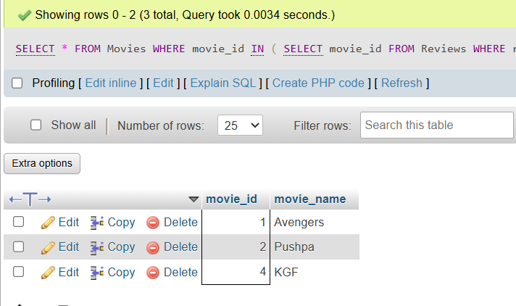

Q4 | Write a nested SQL query to find the names of all sellers from a 'Sellers' table on a Flipkart-style platform who have sold products in every category listed in a 'Categories' table.<br><br><em><strong>Hint:</strong> Use nested subqueries to compare seller's categories with the complete list of categories.</em>
Code | Create table sellers:  CREATE TABLE Sellers ( seller_id INT PRIMARY KEY, seller_name VARCHAR(50) );  Insert record:  INSERT INTO Sellers VALUES (1,'ABC Store'), (2,'XYZ Traders'), (3,'Best Mart');  Create table categories:  CREATE TABLE Categories ( category_id INT PRIMARY KEY, category_name VARCHAR(50) );  Inert record:  INSERT INTO Categories VALUES (1,'Electronics'), (2,'Fashion'), (3,'Home');  Create table product:  CREATE TABLE Products1 ( product_id INT PRIMARY KEY, seller_id INT, category_id INT, FOREIGN KEY (seller_id) REFERENCES Sellers(seller_id), FOREIGN KEY (category_id) REFERENCES Categories(category_id) );  Insert record:  INSERT INTO Products1 VALUES (1,1,1), (2,1,2), (3,1,3), (4,2,1), (5,2,2), (6,3,1);  Final query  SELECT seller_name FROM Sellers s WHERE NOT EXISTS ( SELECT * FROM Categories c WHERE NOT EXISTS ( SELECT * FROM Products1 p WHERE p.seller_id = s.seller_id AND p.category_id = c.category_id ) );
Output | 